2. Data

I analysed in this project : Tokyo.Following are the datasets used in the project:

1. [Japan Hostel Dataset](https://www.kaggle.com/koki25ando/hostel-world-dataset)
2. [Hostel Neighborhood](https://developer.foursquare.com/docs/api)
3. [Tokyo Land Price](https://utinokati.com/en/details/land-market-value/area/Tokyo/)

2.1 Japan Hostel Dataset

The original dataset on Kaggle has the following columns:

* hostel.name: Hostel Name
* City: City name where hostel is located in
* price.from: Minimum Price for 1 night stay
* Distance: Distance from city centre (km)
* summary.score: Summary score of ratings
* rating.band: Rating band
* atmosphere: Rating score of atmosphere
* cleanliness: Rating score of cleanliness
* facilities: Rating score of facilities
* location: Rating score of location
* security: Rating score of security
* staff: Rating score of staff
* valueformoney: Rating score of value for money
* lon: Longitude
* **l**at: Latitude

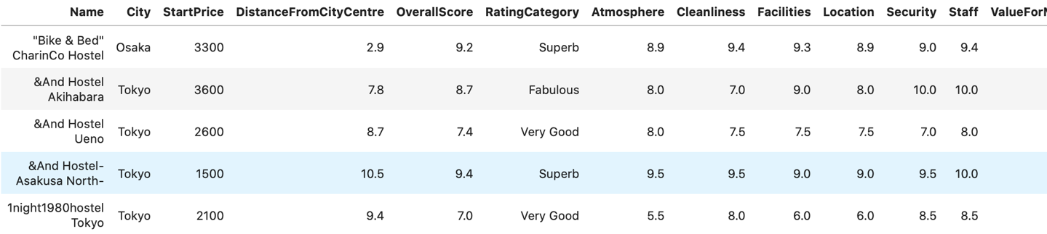Below is a snapshot of the dataset:

2.2 Hostel Neighborhood:

This dataset contains all the neighborhoods or venues within 500m radius of a Hostel. It has the following columns:

* HostelName: Name of the hostel
* VenueName: Name of the venue
* Category: It is the primary category of the venue, for example, Café, Train Station, Restaurant.
* VenueLatitude, VenueLongitude: Coordinates of the venue.

Below is a snapshot of the dataset:

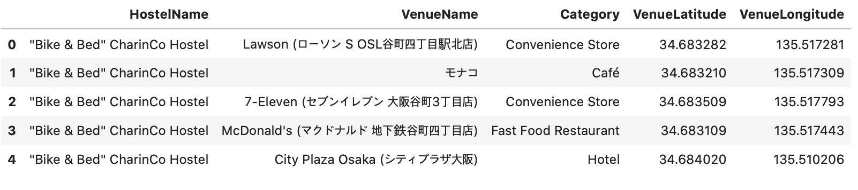

2.3 Tokyo Land Price:

This dataset contains the locality name and the average price of land per square meter. Below is a snapshot:

